CS 340 MODULE SEVEN – Project Two: Grazioso Salvare Dashboard README
Name: Sean Singh
Date: 10/11/2026
Course: CS 340 Client/Server Development
Professor: Jeffrey Scranton

About the Project/Project Title
Grazioso Salvare trains dogs for search-and-rescue work, and the hardest part of finding good candidates is sorting through the records. A nonprofit that runs five animal shelters around Austin, Texas shares its outcome data with Grazioso Salvare, but 10,000 rows of breeds, ages, and outcome codes are not something a trainer wants to scan by hand. This project turns that data into a dashboard where one click narrows the list to dogs that fit a specific kind of rescue work.
Project One built the database layer: the Austin Animal Center Outcomes data loaded into MongoDB, a restricted aacuser account, and CRUD_Python_Module.py, a Python class that handles Create, Read, Update and Delete. Project Two finishes the full stack. ProjectTwoDashboard.ipynb is a Dash web application that sits on top of that same module and gives Grazioso Salvare staff a point-and-click way to search, view and map the shelter data, without writing a single query.
The code is open source so that other rescue organizations can adapt it. This README explains what the dashboard does, why each tool was chosen, how to rebuild the project from scratch, and what problems came up along the way.

Required Functionality
Requirement | How the dashboard meets it
Interactive filter options | A row of radio buttons: Water Rescue, Mountain or Wilderness Rescue, Disaster or Individual Tracking, and Reset. Radio buttons were chosen because the choices are mutually exclusive and all visible at once, so there is nothing to type and no way to pick two rescue types by mistake.
Data table that responds to the filters | A Dash DataTable that reloads from MongoDB whenever a filter is chosen. It shows 10 rows per page, sorts on any column (shift-click for multi-column sorting), has a text filter under every header, and allows one row to be selected at a time.
Geolocation chart | A Dash Leaflet map that places a marker at the selected animal's latitude and longitude. Hovering shows the breed; clicking shows the animal's name.
Second chart | A Plotly pie chart of the breeds currently shown in the table. The eight most common breeds get their own slice and the rest are grouped as "Other," so the chart stays readable even for the unfiltered data.
Grazioso Salvare logo | Displayed in the page header, embedded directly in the page as base64 so it does not depend on a separate file server.
Unique identifier | "Built by Sean Singh | CS 340 Project Two" appears under the title, so it is in every screenshot.

Rescue profiles
Each filter applies the profile from the Rescue Type and Preferred Dog Breeds table in the specifications document. Every condition has to match, so the filters are deliberately narrow: they return dogs that are the right breed, sex and age for that kind of training.
Rescue type | Preferred breeds | Sex | Age (weeks) | Matches
Water | Labrador Retriever Mix, Chesapeake Bay Retriever, Newfoundland | Intact Female | 26 to 156 | 17
Mountain or Wilderness | German Shepherd, Alaskan Malamute, Old English Sheepdog, Siberian Husky, Rottweiler | Intact Male | 26 to 156 | 5
Disaster or Individual Tracking | Doberman Pinscher, German Shepherd, Golden Retriever, Bloodhound, Rottweiler | Intact Male | 20 to 300 | 4
Reset | No filter (all animals) | Any | Any | 10,000

Dashboard Walkthrough
Starting state
When the page opens, Reset is selected and the table holds all 10,000 records from the aac.animals collection, pulled with a "retrieve all" query through the CRUD module. The first row is selected automatically, so the map opens with a marker instead of an empty frame. The pie chart shows the breed mix of the whole shelter population. Domestic Shorthair Mix (a cat breed) is the largest single slice, and a long tail of less common breeds makes up the "Other" slice.
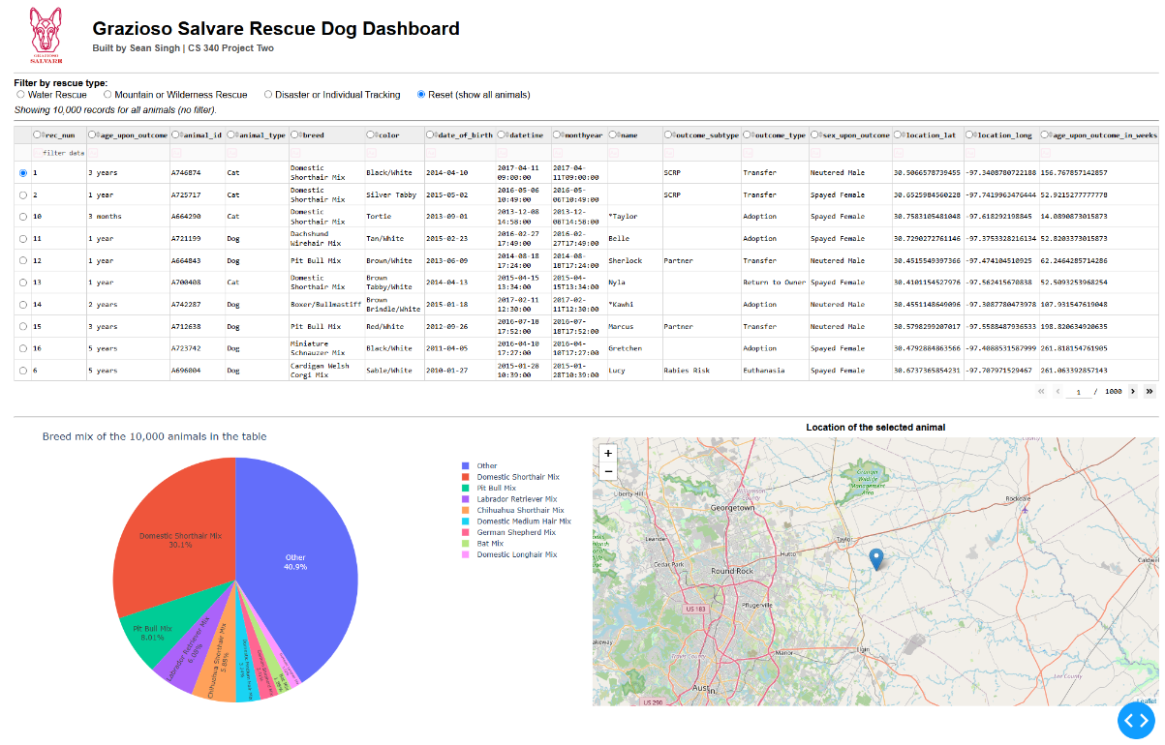
Figure 1. Starting state: Reset selected, 10,000 records, 1,000 pages, the first row selected on the map, and the full breed mix in the pie chart.
Water Rescue
Selecting Water Rescue sends the water profile to MongoDB and returns 17 dogs. Every one of them is an intact female Labrador Retriever Mix between six months and three years old. None of the Chesapeake Bay Retrievers or Newfoundlands in the data meet the sex and age conditions, which is why the pie chart is a single slice. The table drops to two pages, and the map jumps to the first match.
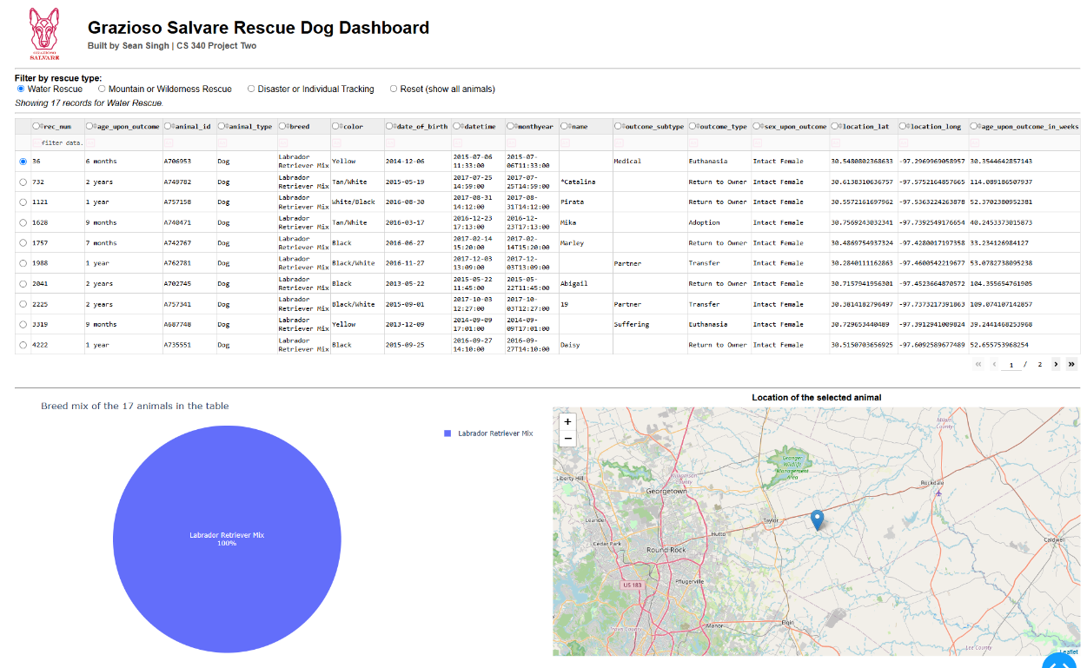
Figure 2. Water Rescue: 17 intact female Labrador Retriever Mixes aged 26 to 156 weeks. The pie chart and the map update to match.
Mountain or Wilderness Rescue
The mountain profile returns 5 intact males across four breeds: two Siberian Huskies, an Alaskan Malamute, a German Shepherd and a Rottweiler. All five fit on one page, so the pager disappears, and the pie chart splits into four slices.
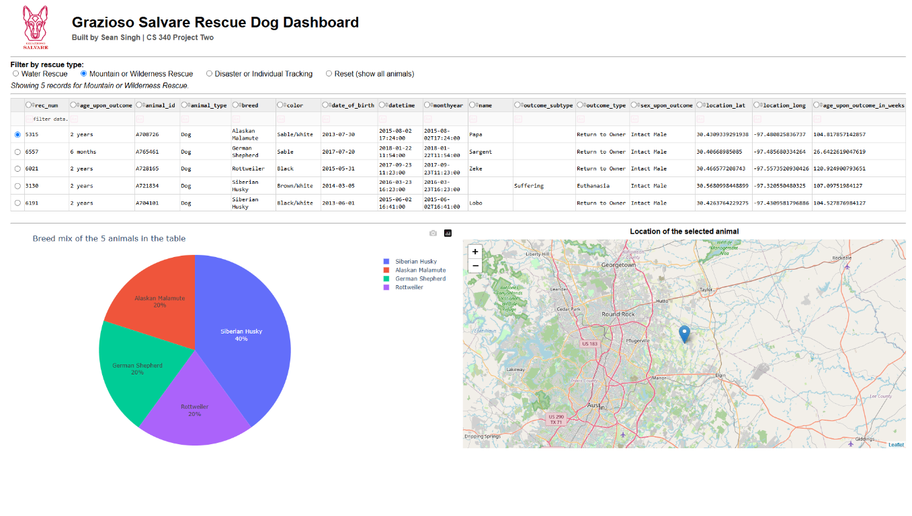
Figure 3. Mountain or Wilderness Rescue: 5 records, four breeds, the map on the first match.
Disaster or Individual Tracking
The disaster profile allows a wider age range (20 to 300 weeks) but a different set of breeds, and it returns 4 dogs: two Rottweilers, a Bloodhound and a German Shepherd. The German Shepherd "Sargent" (A765461) and the Rottweiler "Zeke" (A728165) also appear under Mountain or Wilderness, because both breeds belong to both profiles and both dogs are intact males in the overlapping age range.
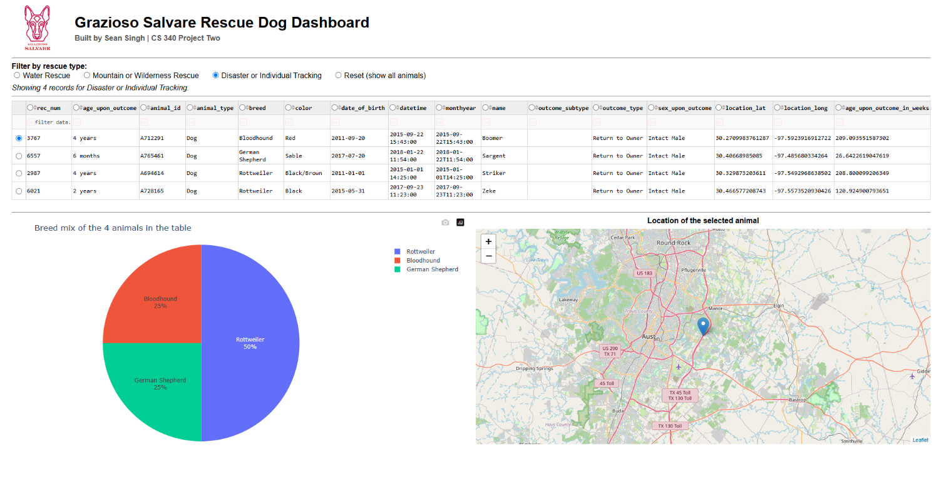
Figure 4. Disaster or Individual Tracking: 4 records, with the map recentered east of Austin on the first match.
Reset
Reset sends an empty filter and brings every widget back to its starting state: 10,000 records, page 1, the first row selected, any typed column filters and sorting cleared, and the original pie chart and map. Comparing Figure 5 with Figure 1 shows that the two are identical.
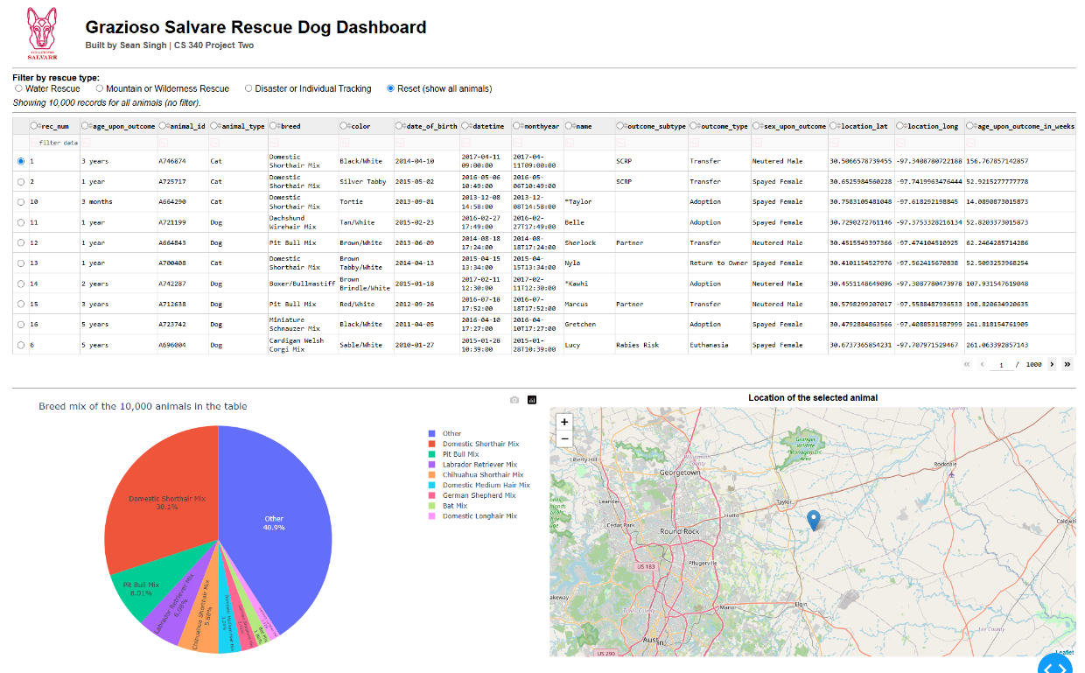
Figure 5. Reset: every widget is back to the unfiltered starting state shown in Figure 1.
Map follows the selected row
The map reads the selected row from the table itself, so choosing a different row moves the marker without another database query. Figures 6 and 7 show the unfiltered table with rows 11 (Belle, a Dachshund Wirehair Mix) and 15 (Marcus, a Pit Bull Mix) selected, and the marker moving to each animal's location.
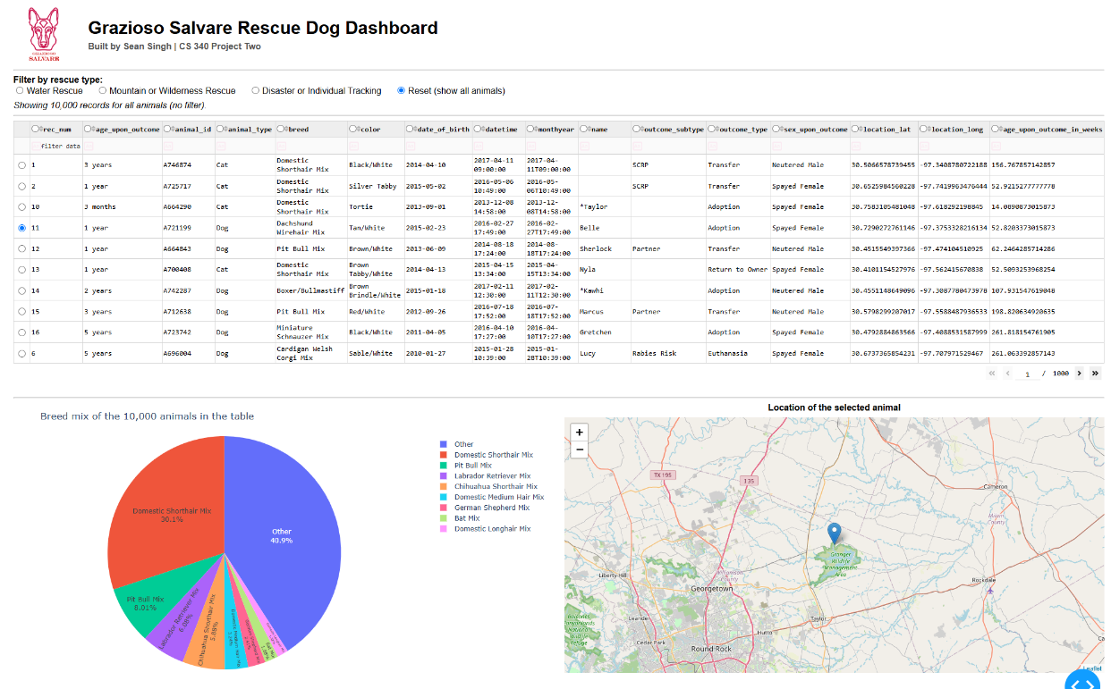
Figure 6. Row 11 selected: the marker moves north-east of Georgetown.
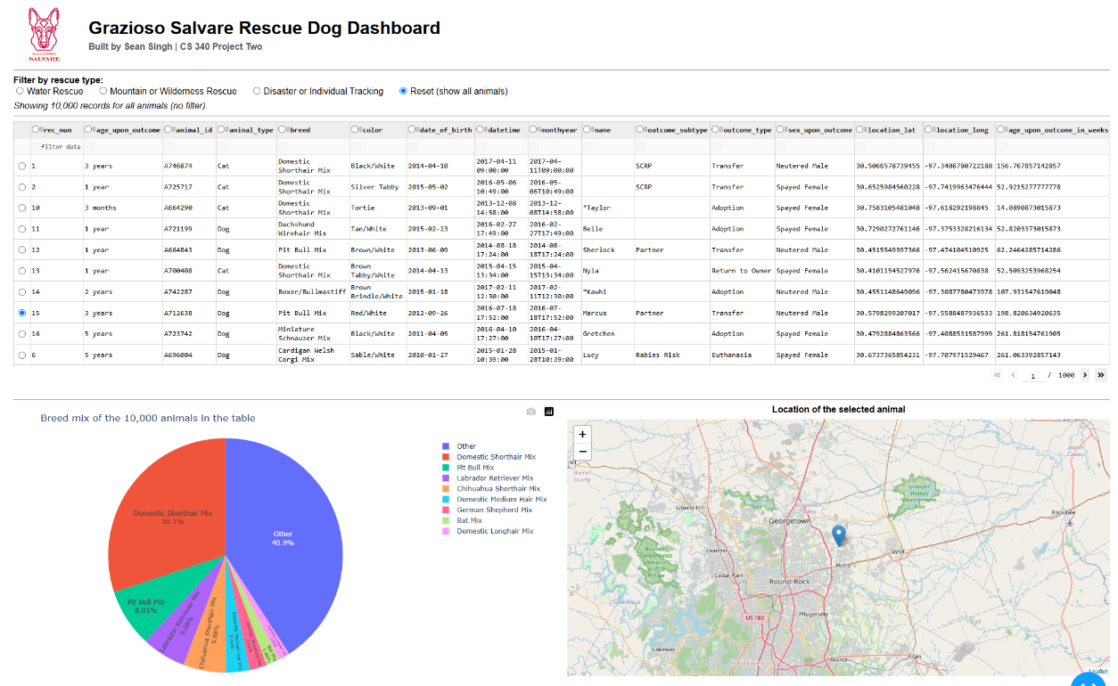
Figure 7. Row 15 selected: the marker moves again without changing the filter.

Test summary
Test | Expected | Result
Dashboard loads with all records | 10,000 records, 1,000 pages | Pass
Water Rescue filter | 17 records, all Labrador Retriever Mix, Intact Female | Pass
Mountain or Wilderness filter | 5 records, Intact Male, preferred breeds only | Pass
Disaster or Individual Tracking filter | 4 records, Intact Male, preferred breeds only | Pass
Reset | Back to 10,000 records and the starting state | Pass
Pie chart follows the table | Slices match the breeds in each filtered result | Pass
Map follows the selected row | Marker moves to the selected animal | Pass
Logo and identifier | Visible in every screenshot | Pass

Tools and Rationale
The dashboard follows the Model-View-Controller pattern, and each layer uses the tool best suited to that job.
Layer | Tool | Role in this project
Model | MongoDB + CRUD_Python_Module.py (PyMongo) | Stores the shelter data and runs every query. The dashboard reaches the database only through the AnimalShelter class.
View | Dash layout: html, dcc, dash_table, Dash Leaflet, Plotly Express | The logo, header, radio buttons, data table, pie chart and map.
Controller | Dash callbacks | Turn a filter choice into a MongoDB query and push the results to every widget.

Why MongoDB for the model
MongoDB is a document database, and the shelter data is a natural fit for documents. Each outcome record is self-contained, and the fields are uneven: many animals have no name, most have no outcome subtype, and the latitude, longitude and age-in-weeks columns were added on top of the original city data. MongoDB stores each record as it is, with no fixed schema to migrate when a column is added, and no empty columns to fill in.
Several qualities make it especially good to work with from Python:
- Documents map directly onto Python dictionaries. PyMongo hands back each record as a dict, and a query is also just a dict. The rescue filters are built in Python with exactly the same structure they would have in the mongo shell, so there is no translation layer or ORM to learn.
- Rich query operators. Each rescue profile is a single query that combines $in (any of several breeds) with $gte and $lte (an age window). MongoDB evaluates all of it on the server, so only the matching dogs travel to the dashboard.
- Projections. read({}, {"_id": 0}) leaves out the ObjectId field, which cannot be converted to JSON for the browser. The filtering happens at the database instead of in Python afterwards.
- Indexes. The breed indexes created in Project One give MongoDB an index to use for the breed condition instead of reading all 10,000 documents.
- Role-based security. The dashboard logs in as aacuser, which has readWrite access on the aac database and nothing else. A leaked password cannot reach other databases or server settings.
- An official, maintained driver. PyMongo is published by MongoDB itself and keeps pace with new server versions.
Why Dash for view and controller
Dash is an open-source Python framework from Plotly for building web dashboards. Its main advantage here is that the whole application, front end included, is written in Python. There is no separate HTML, CSS or JavaScript code base to maintain, which matters for a client that wants to adapt the code later.
- View: app.layout is a tree of components that describes the page. html.Div, html.Img and html.H1 handle structure and branding, dcc.RadioItems provides the filter controls, dash_table.DataTable provides paging, sorting and filtering without extra code, dash_leaflet draws the map, and dcc.Graph displays the Plotly pie chart.
- Controller: callbacks are ordinary Python functions with an @app.callback decorator that names their inputs and outputs. When an input changes (a radio button, a selected row), Dash calls the function and writes its return value into the output component. This makes the flow of data easy to follow. The radio buttons feed update_dashboard, which feeds the table, and the table feeds the pie chart and the map.
- JupyterDash runs the same app from inside a Jupyter notebook, which is how the course environment in Codio works.
pandas sits between the model and the view. The CRUD module returns a list of dictionaries, pandas turns it into a DataFrame for counting breeds and picking out the selected row, and to_dict("records") converts it back into the format the DataTable expects.
Core of the query logic
The three rescue profiles are stored as data in a RESCUE_PROFILES dictionary, and one function turns any of them into a MongoDB filter. An unknown key, including Reset, returns {}, which matches every record:
def build_query(filter_key):
profile = RESCUE_PROFILES.get(filter_key)
if profile is None:
return {}
return {
"animal_type": "Dog",
"breed": {"$in": profile["breeds"]},
"sex_upon_outcome": profile["sex"],
"age_upon_outcome_in_weeks": {"$gte": profile["min_weeks"],
"$lte": profile["max_weeks"]},
}
def fetch_animals(filter_key):
records = db.read(build_query(filter_key), {"_id": 0})
return pd.DataFrame.from_records(records, columns=df.columns)
Because the profiles are data, Grazioso Salvare can add a breed or change an age range by editing one dictionary entry. The radio button labels come from the same dictionary, so the controls and the queries cannot drift apart.
Reproducing the Project
Requirements
Component | Version used | Purpose
MongoDB Server | 7.0.21 | Stores the aac database and the animals collection
mongosh / mongoimport | mongosh 2.5.3 | Shell access, user creation, and data import
Python | 3.11 | Runs the CRUD module and the dashboard
PyMongo | 4.x | MongoDB driver used by CRUD_Python_Module.py
Dash, JupyterDash, dash-leaflet | Dash 2.x | Dashboard framework, notebook runner, and map component
Plotly, pandas | Current releases | Pie chart and data handling
JupyterLab (Codio) | Codio virtual lab | Development and testing environment

Steps
- Load the data. Import aac_shelter_outcomes.csv into the animals collection of the aac database: mongoimport --db aac --collection animals --type=csv --headerline --file=aac_shelter_outcomes.csv (add admin credentials if access control is on). The Project One README covers this and the index setup in detail.
- Create the application user. In mongosh, run use admin, then db.createUser({user: "aacuser", pwd: passwordPrompt(), roles: [{role: "readWrite", db: "aac"}]}).
- Check the database. db.animals.countDocuments() in the aac database should return 10000, and db.getUser("aacuser") in admin should show the readWrite role on aac.
- Install the Python packages if they are not already available: pip install pymongo pandas dash jupyter-dash dash-leaflet plotly.
- Put the files together. ProjectTwoDashboard.ipynb, CRUD_Python_Module.py and Grazioso Salvare Logo.png must be in the same folder.
- Set the credentials. The username and password for aacuser are set in the data-load cell of the notebook. Change them to match your own account.
- Run the notebook with Kernel → Restart Kernel and Run All Cells. The data-load cell should report 10,000 records, and the query test cell should print 17, 5, 4 and 10,000.
- Open the dashboard. The last cell starts the server on port 8050. Open the link it prints. In Codio, the address follows the pattern https://<box-name>-3000.codio.io/proxy/8050/.
- Use it. Pick a rescue type to filter, click a row to move the map, and choose Reset to return to the full data set.

How the Project Was Built
The dashboard was built in small pieces, and each piece was tested before the next one depended on it.
- Verified the environment. Confirmed in mongosh that MongoDB was running, that aac.animals held 10,000 documents, and that aacuser still had the readWrite role. Confirmed that the notebook, logo and CRUD module were in the same code_files folder.
- Imported the libraries and loaded the data through AnimalShelter.read({}, {"_id": 0}) into a DataFrame, and encoded the logo as base64. Printing the record count and the animal-type breakdown proved the CRUD module worked before any widget relied on it.
- Wrote and tested the rescue queries on their own. A loop ran every filter and printed the counts (17, 5, 4, 10,000), so the query logic was proven before it was connected to the interface.
- Built the layout: the header with the logo and identifier, the radio buttons, the data table carried over from the Module Six milestone, and a two-column row for the charts.
- Added the callbacks: one for the filters and table, one for column highlighting, one for the pie chart, and one for the map. The Module Six map callback was reused and changed to center on the selected animal.
- Tested and documented. Ran every filter in the browser, compared the on-screen counts with the notebook's test output, captured the screenshots, and wrote this README.

Challenges and Solutions
Shell commands typed in the wrong place. While starting MongoDB, the server control command was typed at the mongosh test> prompt instead of the Linux prompt, and mongosh rejected it as invalid JavaScript. The fact that mongosh had connected at all showed the server was already running, so that step could be skipped. From then on, Linux commands went in the terminal and database commands went inside mongosh.
ObjectId cannot be sent to the browser. MongoDB's _id field is an ObjectId, which Dash cannot convert to JSON. Instead of deleting the column in pandas after every query, the read call passes the projection {"_id": 0}, so the field never leaves the database.
Empty results could collapse the table. If a query matched nothing, a DataFrame built from an empty list would have no columns, and the table would lose its headers. fetch_animals() passes columns=df.columns, and the chart callbacks return a short "No records match" message instead of trying to plot nothing.
An unreadable pie chart for the full data set. The unfiltered data contains hundreds of breeds, and one slice per breed turned the chart into a blur of thin wedges and overlapping labels. The callback keeps the eight most common breeds and adds the rest together as "Other." The filtered views have only a few breeds, so they are unaffected.
A Reset that didn't fully reset. Re-running the query alone would have left the user on whatever page, sort order and column filter they had before. The filter callback now also returns page 0, an empty filter_query, an empty sort_by, and the first row selected, so Reset really does return every widget to the starting state (compare Figures 1 and 5).
The map pointing at the wrong animal after sorting. Row positions change whenever the table is sorted or filtered. The map callback reads derived_virtual_data and derived_virtual_selected_rows, which describe the table as the user currently sees it, so the selected index always refers to the row that was actually clicked.
Port 8050 already in use. The Module Six milestone notebook used the same port. Its kernel was shut down before the new dashboard was launched, and the notebook is always rerun with Restart Kernel and Run All Cells, so an old server is never left holding the port.
Results that looked too small. Seventeen, five and four dogs out of 5,589 seemed low at first. Checking the conditions one by one showed the queries are correct: each profile requires a specific breed, an intact animal of a specific sex, and a narrow age window all at once. Requiring an intact animal alone removes every spayed or neutered dog from consideration. That is useful information for Grazioso Salvare, not a bug.
Notes for Maintainers
- Changing a rescue profile: edit its entry in RESCUE_PROFILES. The query and the radio button label both update automatically. To add a new rescue type, add a new entry.
- Credentials: the course requires the aacuser password to be written into the notebook. For any real deployment, read it from an environment variable instead (for example os.environ["AAC_PASSWORD"]).
- After editing CRUD_Python_Module.py: restart the kernel. Jupyter caches imported modules and would otherwise keep running the old code.
- Larger data sets: read() loads every match into memory, which is fine for 10,000 records. For much larger data, add server-side paging (DataTable page_action="custom") and pass skip/limit through to MongoDB.
- DataTable deprecation: newer Dash releases mark DataTable as deprecated in favor of Dash AG Grid. It still works in the course environment, but a future upgrade should plan for that switch.

Resources
- MongoDB documentation: https://www.mongodb.com/docs/manual/
- MongoDB query operators: https://www.mongodb.com/docs/manual/reference/operator/query/
- PyMongo documentation: https://pymongo.readthedocs.io/en/stable/
- Dash documentation: https://dash.plotly.com/
- Dash Core Components: https://dash.plotly.com/dash-core-components
- Dash DataTable: https://dash.plotly.com/datatable
- Dash Leaflet: https://www.dash-leaflet.com/
- Plotly pie charts: https://plotly.com/python/pie-charts/
- pandas documentation: https://pandas.pydata.org/docs/
- JupyterLab documentation: https://jupyterlab.readthedocs.io/en/stable/
- Codio: https://www.codio.com/
- OpenStreetMap (map tiles): https://www.openstreetmap.org/copyright
- PEP 8 Style Guide for Python Code: https://peps.python.org/pep-0008/
- Make a README: https://www.makeareadme.com/
Data source: Austin Animal Center. (2020). Austin Animal Center Outcomes [Data set]. City of Austin, Texas Open Data Portal. https://doi.org/10.26000/025.000001
Contact
Name: Sean Singh
Course and University: CS 340 Client/Server Development, Southern New Hampshire University

